

# Capstone Project-1

**Hotel Booking Analysis**

**By- Shashank Someshwar Nanhe**

* For this Given project we got to be analyze the Hotel Booking data. This data set contains booking information for a city hotel and a resort hotel, and includes information such as when the booking was made, length of stay, the number of adults, children, and/or babies, and the number of available parking spaces.
* The main objective of this project is to explore and analyze data to explore important thoughts that govern the bookings and give insights to hotel management ,which can perform various campaigns to boost the business and performance.
* So the work has got divide into following three steps.
  1. Data Collection & Understanding
  2. Data Cleaning & Manipulation
  3. Exploratory Data Analysis (EDA)

EDA will be divided into following 3 analysis.

1. Univariate analysis: Univariate analysis is the simplest of the three analysis where the data you are analyzing is only one variable.
2. Bivariate analysis: Bivariate analysis is where you are comparing two variables to study their relationships.
3. Multivariate analysis: Multivariate analysis is similar to Bivariate analysis but you are comparing more than two variables.

* After collecting data it is very important to understand your data. So data obtained at hotel Booking analysis. Which had 119390 rows and 32 columns. So let’s get started from 32 columns.

Data Description:

**hotel:** Resort Hotel or City Hotel

**is_canceled** : Value indicating if the booking was canceled (1) or not (0)

**lead_time** : Number of days that elapsed between the entering date of the booking and the arrival date

**arrival_date_year** : Year of arrival date

**arrival_date_month** : Month of arrival date **arrival_date_week_number** : Week number of year for arrival date **arrival_date_day_of_month** : Day of arrival date **stays_in_weekend_nights** : Number of weekend nights **stays_in_week_nights** : Number of week nights.

**adults** : Number of adults **children** : Number of children **babies** : Number of babies **meal** : Type of meal booked. **country** : Country of origin.

**market_segment** : Market segment designation. (TA/TO) **distribution_channel** : Booking distribution channel.(T/A/TO) **is_repeated_guest** : is a repeated guest (1) or not (0)

**previous_cancellations** : Number of previous bookings that were cancelled by the customer prior to the current

booking

**previous_bookings_not_canceled** : Number of previous bookings not cancelled by the customer prior to the current booking

**reserved_room_type** : Code of room type reserved.

**assigned_room_type** : Code for the type of room assigned to the booking.

**booking_changes** : Number of changes made to the booking from the moment the booking was entered on the PMS until the moment of check-in or cancellation

**deposit_type** : No Deposit, Non Refund , Refundable. **agent** : ID of the travel agency that made the booking **company** : ID of the company/entity that made the booking .

**days_in_waiting_list** : Number of days the booking was in the waiting list before it was confirmed to the customer

**customer_type** : type of customer. Contract,Group,transient,Transient party.

**adr** : Average Daily Rate as defined by dividing the sum of all lodging transactions by the total number of staying nights

**required_car_parking_spaces** : Number of car parking spaces required by the customer **total_of_special_requests** : Number of special requests made by the customer (e.g. twin bed or high floor) **reservation_status** : Reservation last status.

* There were 4 columns company, agent, country and children with missing values.

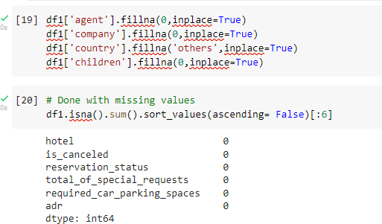

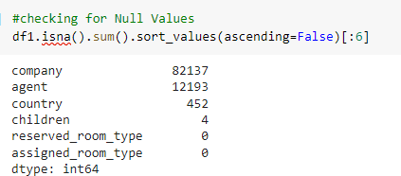

* 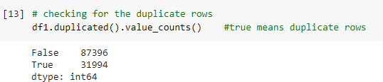Handling Duplicates: Data had 31994 duplicates values. So we dropped it from the data.
* Feature Engineering:

We created 2 new columns 1)‘Total_People’ = from the Children, adults, babies.

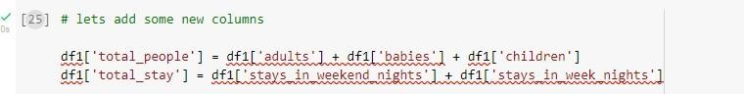2) ‘Total_stay’ = From weekend nights and weekdays night

* City hotels is the most preferred hotel type by the guests. We can say City hotel is the busiest hotel.

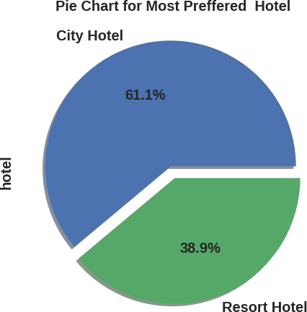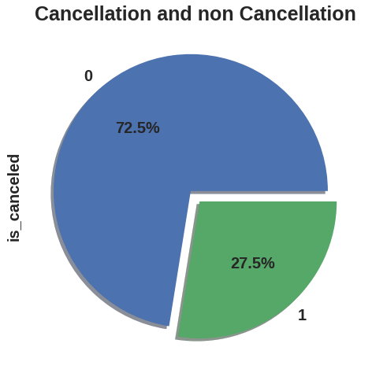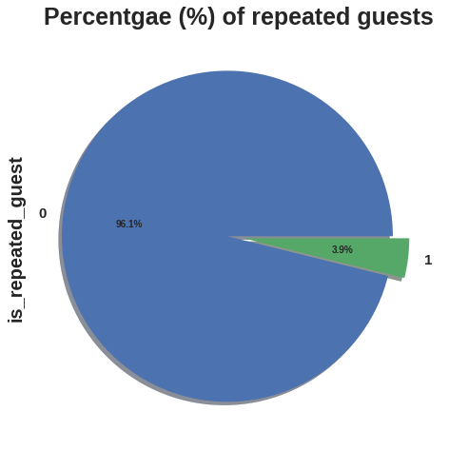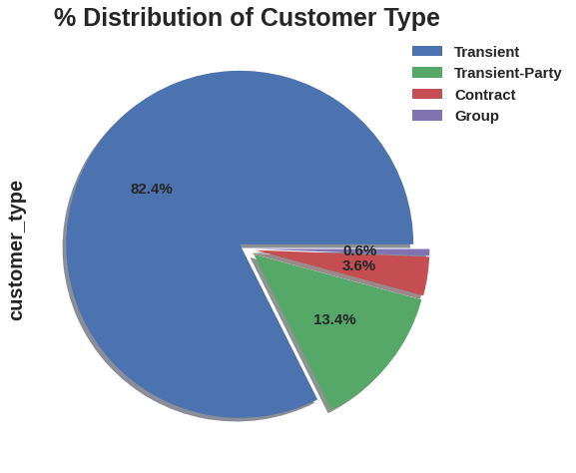

●

**Conclusions:**

* 27.5 % bookings were got cancelled out of all the bookings
* .Only 3.9 % people were revisited the hotels. Rest 96.1 % were new guests. Thus retention rate is low.
* Most of the customers/guests were Transient type(82.4%). And transient party were 13.4% and 0.6 belongs to group. Remaining guests belongs to Contract type.

**Contract**-when the booking has an allotment or other type of contract associated to it

**Group** -when the booking is associated to a group

**Transient-**when the booking is not part of a group or contract, and is not associated to other transient booking

**Transient-party-**when the booking is transient, but is associated to at least other transient booking

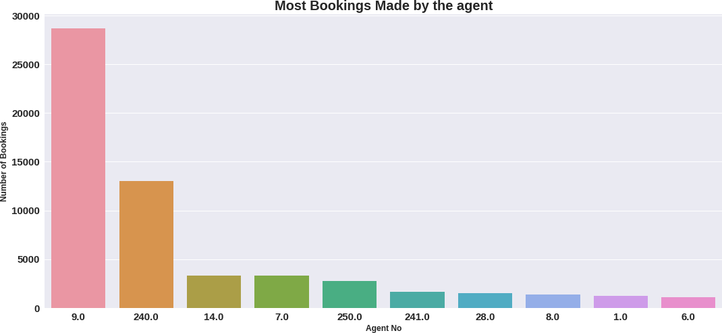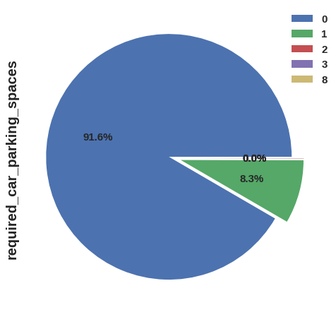

## Conclusions:

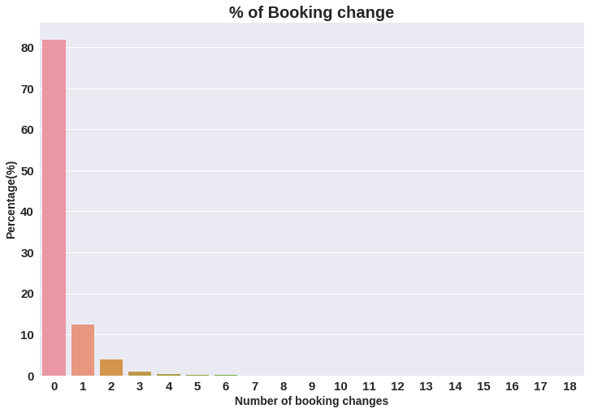

●

* The percentage of 0 changes made in the booking was more than 82 %. Percentage of Single changes made was about 10%.
* Agent Id no -9 made the highest bookings which is more than 28721.
* Most of the customers(91.6%) do not require car parking spaces. Only 8.3 % people required only 1 car parking space.

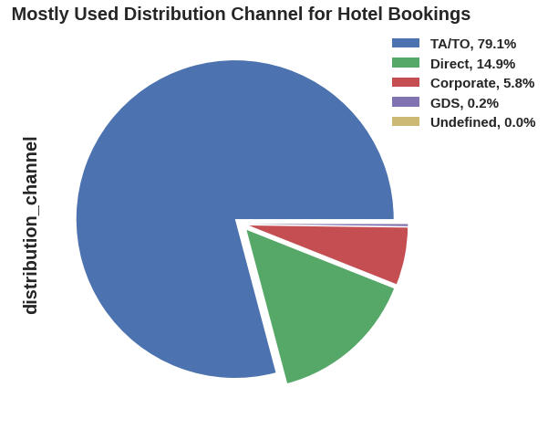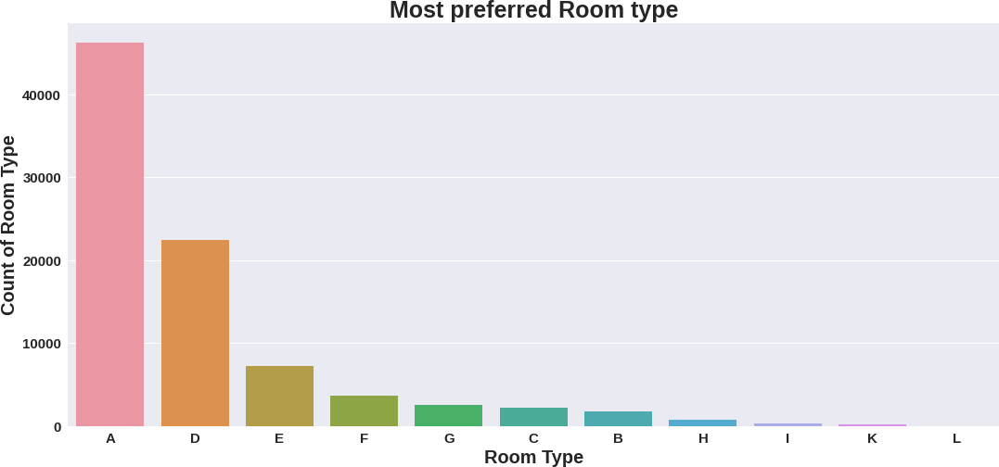●

## Conclusions:

* 79.1 % bookings were made through TA/TO (travel agents/Tour operators).Second most channel is direct.
* Room type ‘A’ is most preferred by the guests second most preferred is ‘D’.
* Almost 98.7% of the guests prefer ‘No deposit’ type of criterion while booking hotels.

## Conclusions:

* BB( Bed & Breakfast) is the most preferred type of meal by the guests.
* Full Board i.e. FB is least preferred.
* HB (Half Board) and SC(Self Catering) are

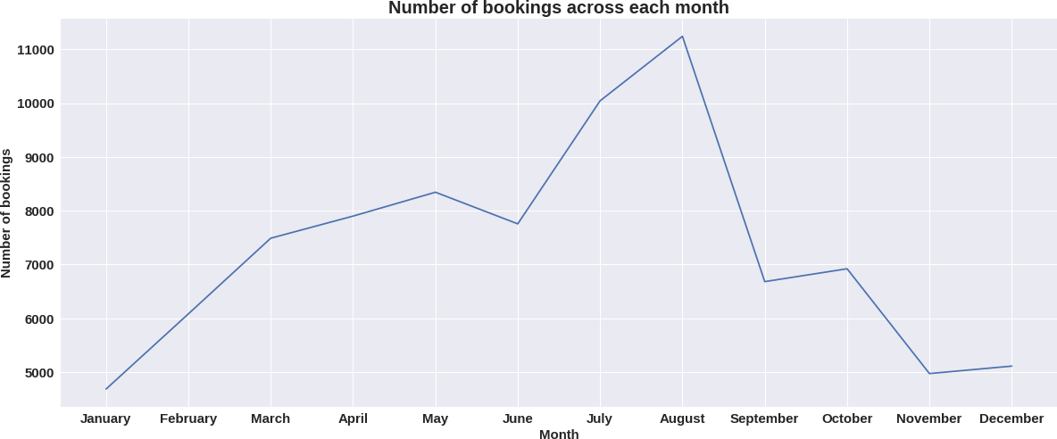equa●lly preferred.

* As we can see in the line chart, from June to September most of the bookings happened. It’s Summer time. After September bookings Starts declining.

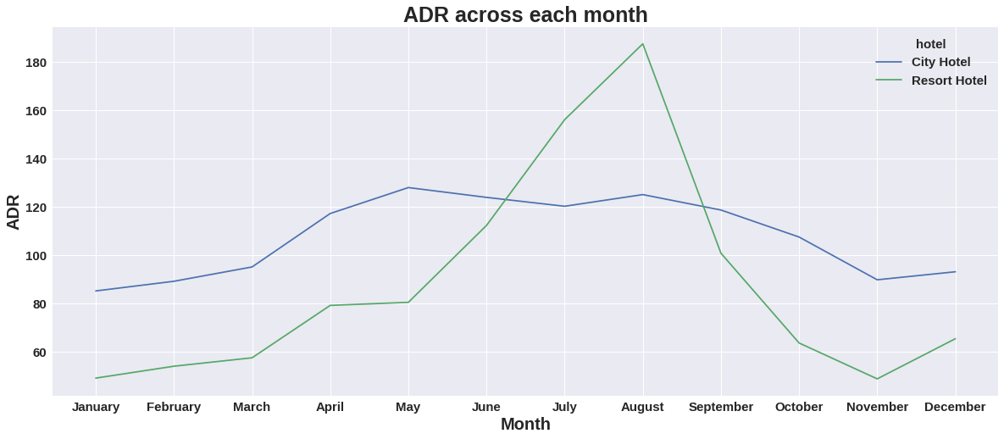

## Conclusions:

* Resort hotels had the highest adr in June ,July and August than the City hotels. But in other months adr of Resort hotel was less than the City hotels.
* Thus we can say that, the January, February, March, April ,November and December are the good months

for customers to get good adr

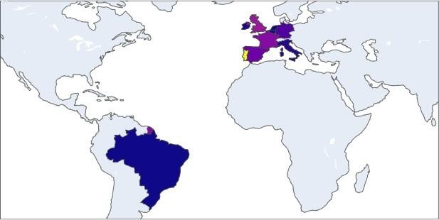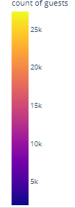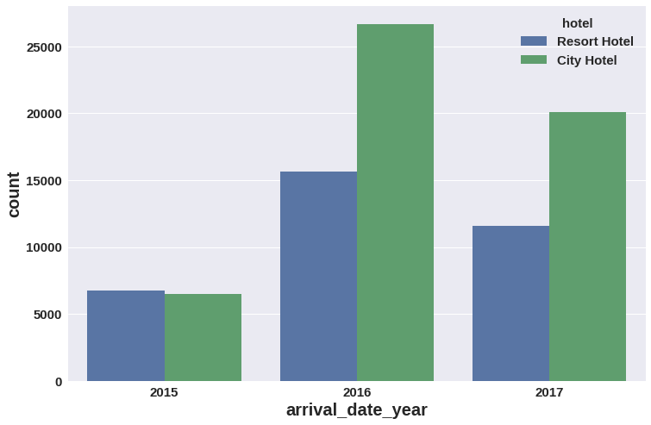

●

## Conclusions:

* Maximum number of guests were from Portugal. i.e. more than 25000 guests.
* After Portugal, GBR(Great Brittan),France and Spain are the countries from where most of the guests came.
* Most of the bookings for City hotels and

Resort hotel were happened in 2016. As we can see Most of the bookings were for City hotels.

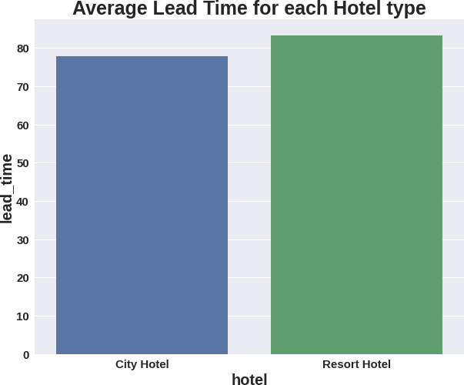 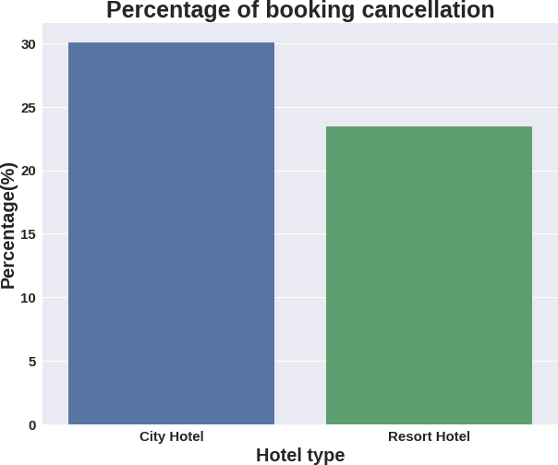

●

## Conclusions:

* Average ADR for city hotel is high as compared to resort hotels. These City hotels are generating more revenue than the resort hotels.
* Average lead time for resort hotel is high. It means people plan their trip too early. Usually people prefer resort hotels for longer stays. That’s why people plan early
* Booking cancellation rate is high for City hotels which almost 30 %.

## Conclusions:

* Waiting time period for City hotel is high as compared to resort hotels. That means city hotels are much busier than Resort hotels.
* Resort hotels has the most repeated guests. In order to get increase the count of repeated guests hotel

management need to take the valuable feedbacks from the guests and try to give good service.

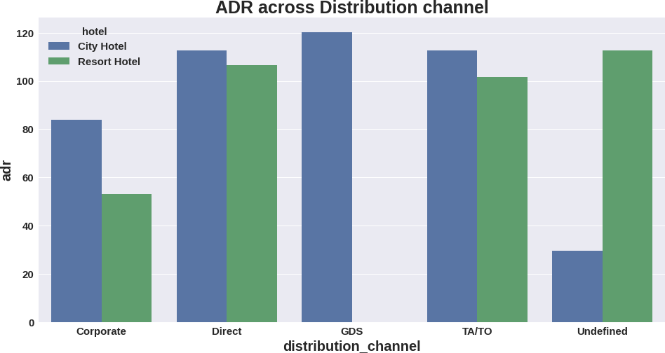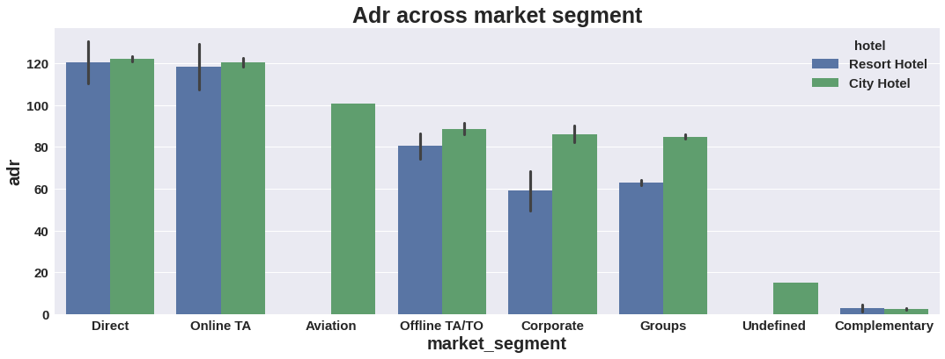

## Conclusions:

### Distribution channel:

* 'Direct' and 'TA/TO' has almost equal adr in both type of hotels which is high among other channels.
* GDS has high adr in 'City Hotel' type. GDS needs to increase Resort Hotel bookings. From this we can say that “Direct” and ‘TA/TO’ are generating more revenue than the other channels.

### Market Segment:

* Here “Direct” and ‘Online Travel Agency’ has high adr for both hotel types. Aviation segment needs to increase Resort hotel bookings.

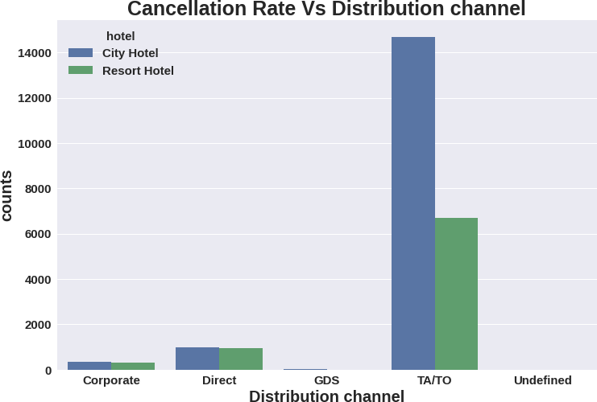 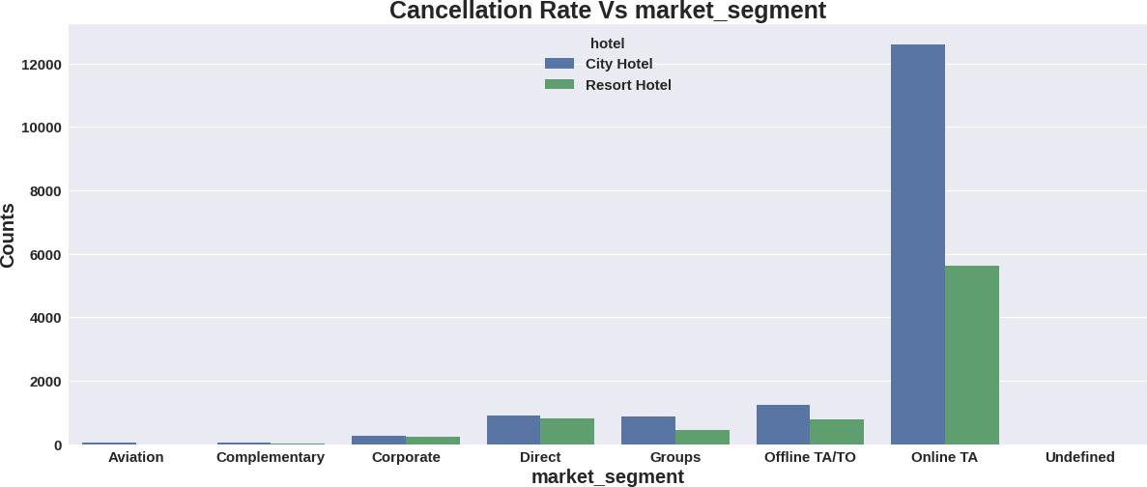

## Conclusions:

### Distribution channel:

* ‘TA/TO’ distribution channel has highest cancellations for city hotels and more than 6000 cancellations for resort hotels. In order to reduce the cancellations they should improve their cancellation policies and deposit policies.

### Market Segment:

* ‘Online TA/TO’ market segment has highest cancellations for city hotels.

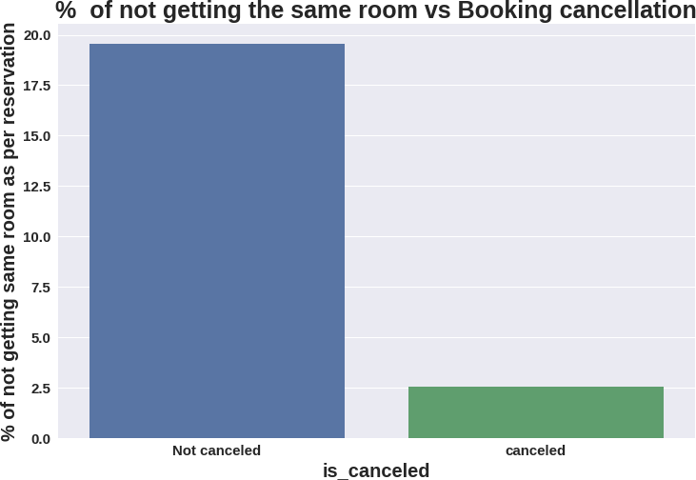

## Conclusions:

* Almost 19 % people did not canceled their bookings even after not getting the same room which they

reserved while booking hotel. Only 2.5 % people cancelled the booking.

* Thus not getting the same room as per reserved room is not the reason for booking cancellations.

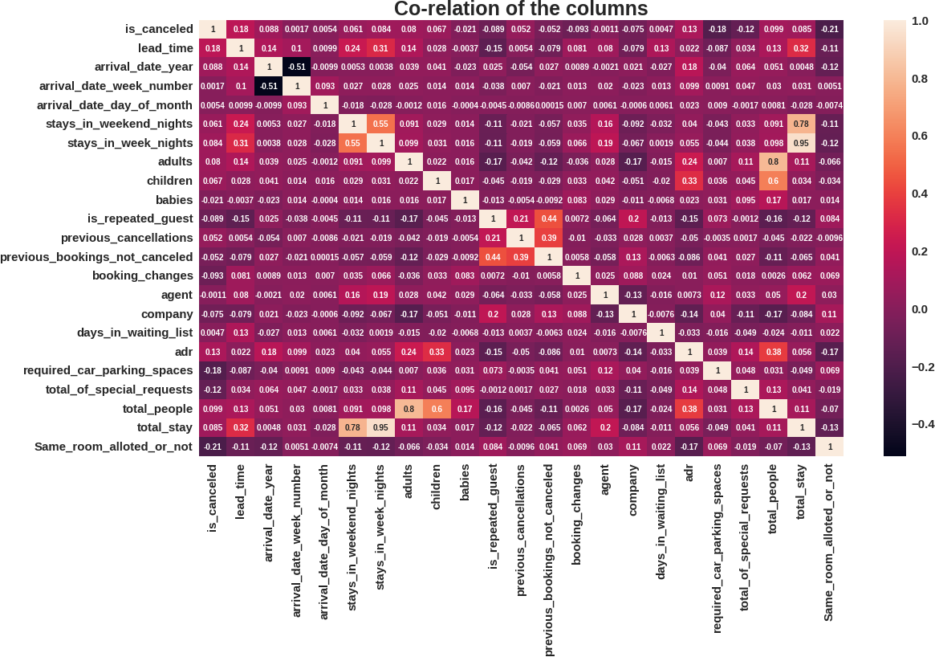

## Conclusions:

* is canceled and same_room_alloted_or_not are negatively correlated. Not getting the same room as per reserved room is not the reason for booking cancellations.
* lead-time and total stay is positively correlated means more is the stay of customer more will be the lead time.
* ADR and total people are highly correlated. That means more the people

more will be adr.High adr means high revenue

* is_repeated_guest and previous_bookings Not_canceled has strong correlation. May be repeated guests are not more likely to cancel their bookings.

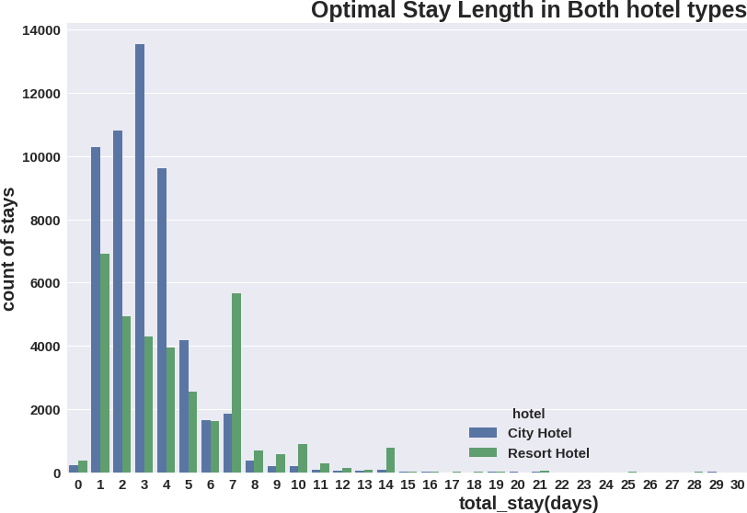 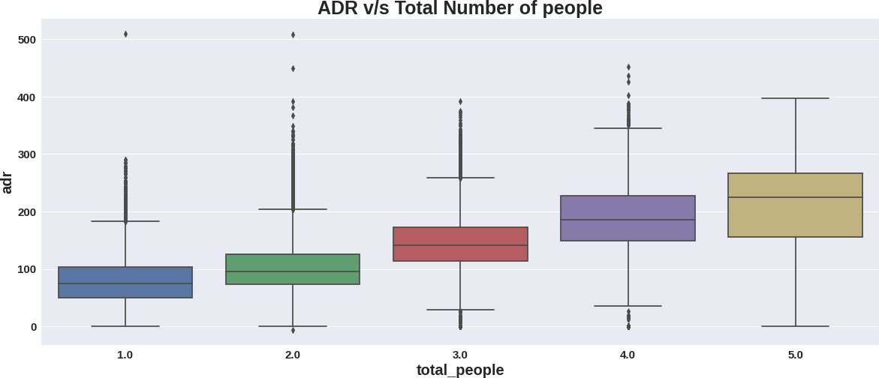

## Conclusions:

* Optimal stay in both the type hotel is less than 7 days. Usually people stays for a week.
* For stay more than 7 days people likes to stay in Resort hotels. As we can see after 7 days City Hotel

Bookings are very less as compared to Resort hotels.

* As we saw in Correlation heatmap, total people and adr are positively correlated. Thus for 2 people ,adr is almost 100 and for 5 people its more than 200.
* Thus more the people more will revenue of the hotels.

